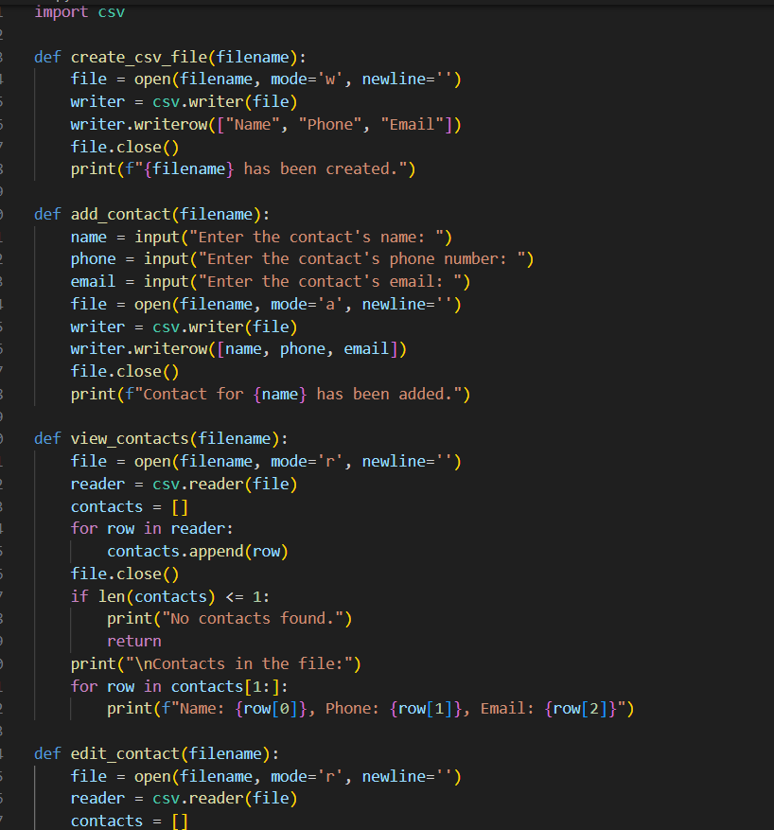

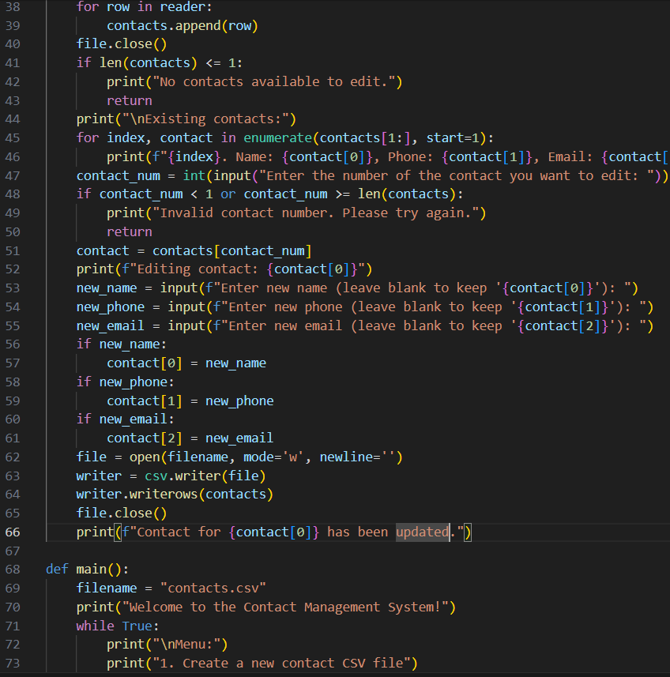

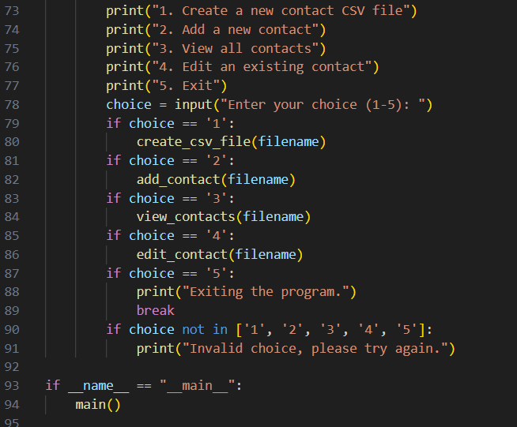

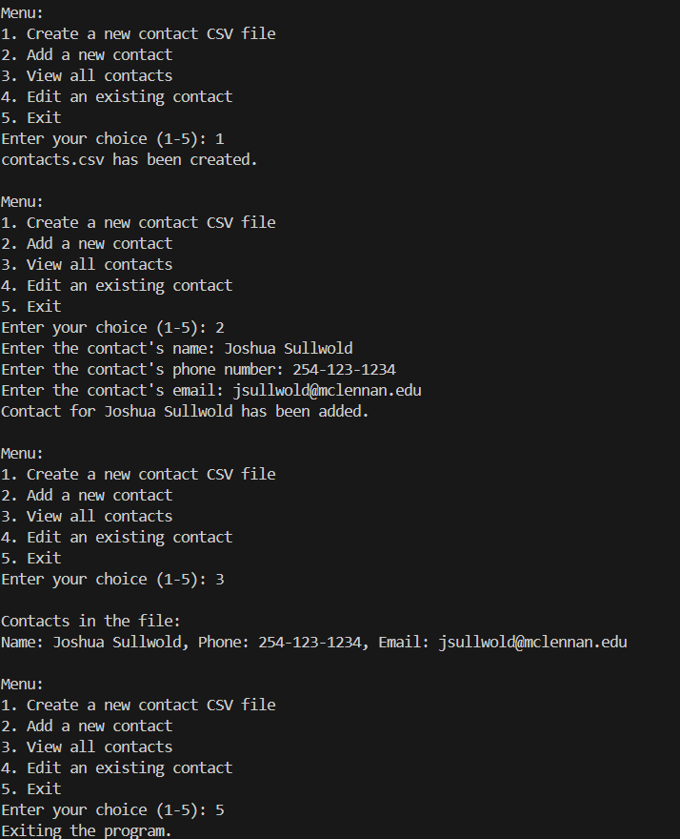

import csv

def create_csv_file(filename):

file = open(filename, mode='w', newline='')

writer = csv.writer(file)

writer.writerow(["Name", "Phone", "Email"])

file.close()

print(f"{filename} has been created.")

def add_contact(filename):

name = input("Enter the contact's name: ")

phone = input("Enter the contact's phone number: ")

email = input("Enter the contact's email: ")

file = open(filename, mode='a', newline='')

writer = csv.writer(file)

writer.writerow([name, phone, email])

file.close()

print(f"Contact for {name} has been added.")

def view_contacts(filename):

file = open(filename, mode='r', newline='')

reader = csv.reader(file)

contacts = []

for row in reader:

contacts.append(row)

file.close()

if len(contacts) <= 1:

print("No contacts found.")

return

print("\nContacts in the file:")

for row in contacts[1:]:

print(f"Name: {row[0]}, Phone: {row[1]}, Email: {row[2]}")

def edit_contact(filename):

file = open(filename, mode='r', newline='')

reader = csv.reader(file)

contacts = []

for row in reader:

contacts.append(row)

file.close()

if len(contacts) <= 1:

print("No contacts available to edit.")

return

print("\nExisting contacts:")

for index, contact in enumerate(contacts[1:], start=1):

print(f"{index}. Name: {contact[0]}, Phone: {contact[1]}, Email: {contact[2]}")

contact_num = int(input("Enter the number of the contact you want to edit: "))

if contact_num < 1 or contact_num >= len(contacts):

print("Invalid contact number. Please try again.")

return

contact = contacts[contact_num]

print(f"Editing contact: {contact[0]}")

new_name = input(f"Enter new name (leave blank to keep '{contact[0]}'): ")

new_phone = input(f"Enter new phone (leave blank to keep '{contact[1]}'): ")

new_email = input(f"Enter new email (leave blank to keep '{contact[2]}'): ")

if new_name:

contact[0] = new_name

if new_phone:

contact[1] = new_phone

if new_email:

contact[2] = new_email

file = open(filename, mode='w', newline='')

writer = csv.writer(file)

writer.writerows(contacts)

file.close()

print(f"Contact for {contact[0]} has been updated.")

def main():

filename = "contacts.csv"

print("Welcome to the Contact Management System!")

while True:

print("\nMenu:")

print("1. Create a new contact CSV file")

print("2. Add a new contact")

print("3. View all contacts")

print("4. Edit an existing contact")

print("5. Exit")

choice = input("Enter your choice (1-5): ")

if choice == '1':

create_csv_file(filename)

if choice == '2':

add_contact(filename)

if choice == '3':

view_contacts(filename)

if choice == '4':

edit_contact(filename)

if choice == '5':

print("Exiting the program.")

break

if choice not in ['1', '2', '3', '4', '5']:

print("Invalid choice, please try again.")

if __name__ == "__main__":

main()

print('Created by Ben Andrews')